SUNDAY, November 9, 2025
9:45 am Sunday School
11:00 am Worship Service/Communion
12:30 pm Ministry Meeting – Security Team

TUESDAY, November 11, 2025
12:30 pm Forever Young @ “Golden Corral”
6:00 pm After the Sermon
7:00 pm Phone-In Prayer Meeting

THURSDAY, November 13, 2025
6:00 pm Women’s Bible Study

CHURCH OFFICE HOURS THIS WEEK:

Mon., Nov. 10 Tues., Nov. 11 Wed., Nov. 12 Thurs., Nov. 13
9:30 am – 1 pm 9:30 am – 1 pm 9:30 am – 1 pm 9:30 am – 1 pm

How Do I Join Upper Seneca Baptist Church

- By Salvation ~ By professing faith in Jesus Christ and following Him in believer’s baptism.
- By Transfer of Letter ~ By transferring your membership from another Baptist Church.
- By Statement of Faith ~ By statement of faith in Jesus Christ.

If you have not been baptized by immersion since your conversion, you will need to follow the Lord in believer’s baptism.

When Do I Join?

At the close of every worship service as we sing the “Invitation Hymn”, the pastor stands facing the congregation. Walk to him and tell him you want to join the church or make some other decision.

Pastor Dennis Felder
Weather Policy

If the church cancels or postpones any service or activity due to inclement weather or wintery conditions, a cancelation notice will appear on the church’s Facebook page, church’s website, through church email, and on the church’s voice recorder. To access the church’s voice recorder, please dial (301) 972-3686. The church will only post a cancelation message if a service or activity is canceled or postponed.
pastordennis@usbchurch.org

23401 Davis Mill Road
Germantown, MD 20876
Phone: (301) 972-3686

Nursery & Children’s Church available
Church Office 301-972-3686

E-Mail – Church@USBChurch.org
Web Site – www.USBChurch.com

Scan this QR code which points to our Church’s Main Web Page
(http://www.USBChurch.com)

Upper Seneca Baptist Church

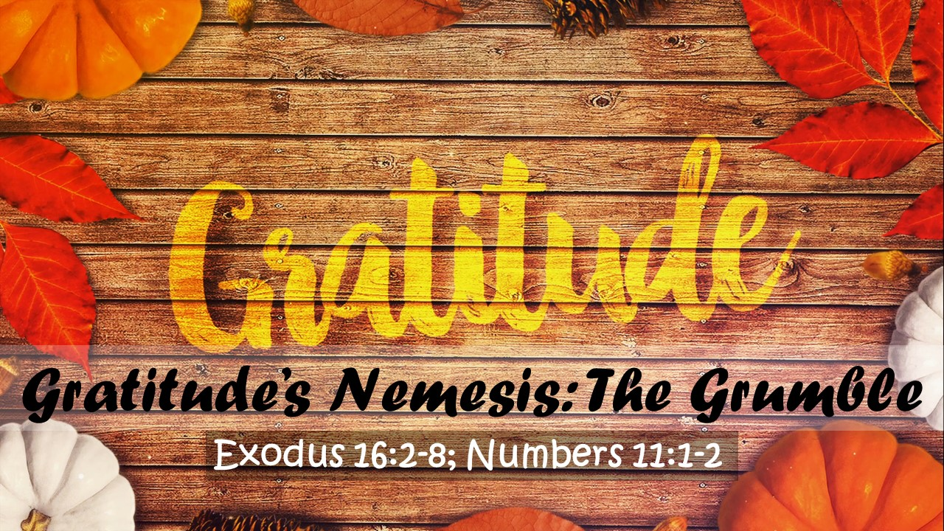

Impacting The Kingdom Of God
Psalm 31:19
Isaiah 40:28-31
One Person At A Time

Upper Seneca Baptist Church
11:00 am Sunday Worship
Sunday Worship
November 9, 2025

Call to Worship

*Song “Blessed Be Your Name” Congregation

Meet and Greet

*Song “My Heart Is Filled with Thankfulness” Congregation

Prayer/Welcome Pastor Dennis

*Song “Counting My Blessings” Congregation

**Message Pastor Dennis
“GRATITUDE’S NEMESIS: THE GRUMBLE”
Exodus 16:2-8; Numbers 11:1-2 (NIV)

Special “Gratitude” Richard Doody



*Song “The Blessing” Congregation

*Denotes Congregation standing
**Children will be dismissed to their classrooms following the Sermon Video (prior to the Message).
Words to hymn music printed by permission CCLI License #1159459

Your tithes and offerings will be collected at the end of the service upon leaving.



Sunday, Nov. 9, Communion Sunday
Sunday, Nov. 9, Security Ministry Team Meeting
Tuesday, Nov. 11, Forever Young @ “Golden Corral”
Tuesday, Nov. 11, After the Sermon
Tuesday, Nov. 11, Prayer Meeting
Thursday, Nov. 13, Women’s Bible Study
Sunday, Nov. 16, AV & Website Ministry Team Meeting
Sunday, Nov. 16, Thanksgiving Food Drive Ends
Sunday, Nov. 16, Shoe Box Collection Due
Sunday, Nov. 29, Church Christmas Decorating


Looking for childcare or know someone who is? Agape Childcare and Preschool has openings. The daycare center is under the direction and proprietorship of Ruth D’Monte (one of our faithful church members If you would like more information about the daycare center or about enrolling your children, please see Ruth.

Part-Time Associate Pastor/
Outreach Minister Wanted


Upper Seneca Baptist Church is seeking a dedicated and spiritually driven individual to serve as a Part-Time Associate Pastor/Outreach Minister. This role is ideal for someone who is passionate about sharing the Gospel, building community relationships, and supporting the spiritual growth of our congregation. For additional information, go to www.USBChurch.com or see Pastor Dennis.

Gratitude – “Gratitude’s Nemesis:
The Grumble”
By Pastor Dennis Felder
November 9, 2025

Scripture: Exodus 16:2-8; Numbers 11:1-2 (NIV)

Synopsis: In life, we face two opposing forces that are always at odds with one another: Gratitude vs. Grumbling. In the end, one will win. With God’s help, grumbling can be defeated.

What I know about grumbling:

I. Grumbling is ________________________.

Exodus 16:2-3 – In the desert the whole community grumbled against Moses and Aaron. The Israelites said to them, “If only we had died by the Lord’s hand in Egypt! There we sat around pots of meat and ate all the food we wanted, but you have brought us out into this desert to starve this entire assembly to death.”

When we grumble, others will join in.

Grumbling is based on short memories.

Psalm 28:7 – The Lord is my strength and my shield; my heart trusts in him, and he helps me. My heart leaps for joy, and with my song I praise him.

II. Grumbling hurts _____________________.

Exodus 16:4-8 – Then the Lord said to Moses, “I will rain down bread from heaven for you. The people are to go out each day and gather enough for that day. In this way I will test them and see whether they will follow my instructions. On the sixth day they are to prepare what they bring in, and that is to be twice as much as they gather on the other days.” So Moses and Aaron said to all the Israelites, “In the evening you will know that it was the Lord who brought you out of Egypt, and in the morning you will see the glory of the Lord, because he has heard your grumbling against him. Who are we, that you should grumble against us?” Moses also said, “You will know that it was the Lord when he gives you meat to eat in the evening and all the bread you want in the morning, because he has heard your grumbling against him. Who are we? You are not grumbling against us, but against the Lord.”

When you grumble, anyone can become a target of your wrath.

James 5:9 – Don’t grumble against one another, brothers and sisters, or you will be judged. The Judge is standing at the door!

Even when you grumble, God is still at work.

III. Grumbling angers ____________________.

Numbers 11:1-2 – Now the people complained about their hardships in the hearing of the Lord, and when he heard them his anger was aroused. Then fire from the Lord burned among them and consumed some of the outskirts of the camp. When the people cried out to Moses, he prayed to the Lord and the fire died down.

When you grumble, you unleash God’s anger.

Nahum 1:2 – The Lord is a jealous and avenging God; the Lord takes vengeance and is filled with wrath. The Lord takes vengeance on his foes and vents his wrath against his enemies.

Grumbling is sign that you do not trust God.

Philippians 2:14 – Do everything without grumbling or arguing,

Who will win the battle for your heart? Grumbling or Gratitude?

If you would like to listen to the sermon on-line, please visit our website at www.USBChurch.org

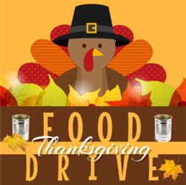
From October 26 to November 16th, USBC will be having a Thanksgiving Food Drive to help families in need during the Thanksgiving season. Please make certain that the non-perishable food you donate has not expired. A list of items needed are on the table in the back of the sanctuary. These items can be dropped off in the church’s foyer and will be distributed at a later date.


It is that special time of year again – CHRISTMAS! As we prepare for the all the Christmas activities at the church, we will be decorating our church building for this festive season. On Saturday, November 29 at 10 a.m., we need your help in putting up our Christmas decorations. If you can help with our Christmas decorating, please sign up in the foyer.


Judith Namme
B co, 2-13th IN REGT
4380 Century Division Ave
Fort Jackson, SC 29208-6809


Brian & Kate Alman
543 Terra Springs Circle
Volo, IL 60020

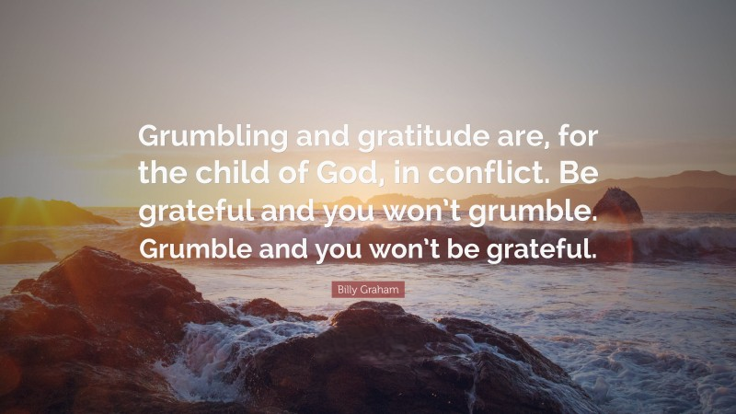



The following activities will be canceled in November.

After the Sermon Bible Study (Nov. 25th)
Prayer Meeting (Nov. 25th)
Thursday Night Women’s Bible Study (Nov. 27th)
Church Office Closed (Nov. 27th – Nov. 30th)
Dive Deeper Bible Study (Nov. 30th)


Today, I ask that you prepare your heart as we celebrate communion during our Sunday morning worship service. Let this be a special time of self-reflection and change as you recall the great sacrifice that Christ made for you. He gave His all so that you could experience the true meaning of life.

As you leave the service today, a basket to your right is there to receive Benevolence Offerings for USBC.



During the month of November, USBC will be focusing on “thankfulness” and “gratitude”. One way that we will be expressing our “thankfulness” and “gratitude” is with Thanksgiving Flags. Starting on Sunday, November 2, orange and yellow flags will be placed in the church foyer. The purpose of the flags is to give you an opportunity to express your “thankfulness” to someone or for something by writing your message on the flags. Once you write your message on the flag, you can place it in the designated arrangement. Later, we will dedicate these blessings of thanksgiving to the Lord.


The Forever Young Luncheon will take place on Tuesday, November. 11 at 12:30 p.m. We will be meeting at the Golden Corral in Frederick, MD. Remember, anyone is welcome.


On Tuesday, November 25 at 6:30 p.m., USBC will be having a special Thanksgiving Gathering. We will gather around the table and share our thankfulness in an enjoyable and creative way. The Thanksgiving Gathering is for young and old alike to come together and celebrate the Thanksgiving season.
THANKSGIVING
GATHERING


Operation Christmas Child delivers great joy and the Good News of Jesus Christ to children in need around the world through gift‍-‍filled shoeboxes. Each box packed full of quality toys, school supplies, and personal care items becomes a tangible expression of God’s immense love for the child. For many, it is their first gift ever! Delivered by our local church partners, shoebox gifts provide an opportunity to present the Gospel to boys and girls in a clear, child-friendly way. All packed shoeboxes must be returned to the church no later than Sunday, November 23. At the conclusion of our worship service on November 23, we will finish packing all shoeboxes that still need to be completed.


I love a good Christmas Party and USBC will be having such a celebration. We invite all to attend the church’s Christmas Party on Saturday, December 13, 2025 at 4 p.m. This festive celebration will take place at the Golden Corral (5621 Spectrum Drive, Frederick, MD 21703). During our time together we will have some fun activities and prizes. Everyone is invited and if you are planning to attend the Christmas Party at the Golden Corral, please sign-up in the foyer. The cost is $17.99, plus the cost of a drink. Children’s cost will be based upon their age; it will range from $8.99 to $9.99. Each one will be responsible for the purchase of their meal and tip.
December 13 at 4:00 pm



Young Adult Ministry Team – Nov. 2
Security Ministry Team – Nov. 9
AV and Website Ministry Team – Nov. 16

