SUNDAY, December 8, 2024
9:45 am Sunday School
11:00 am Worship Service/Communion

MONDAY, December 9, 2024
6:00 pm Church Council

TUESDAY, December 10, 2024
12:30 pm Forever Young @ “Golden Corral”
6:00 pm After the Sermon
7:00 pm Phone-In Prayer Meeting

THURSDAY, December 12, 2024
6:30 pm Women’s Bible Study

SATURDAY, December 14, 2024
4:00 pm USBC Christmas Party @ “Golden Corral”

CHURCH OFFICE HOURS THIS WEEK:

Mon., Dec. 9 Tues., Dec. 10 Wed., Dec. 11 Thurs., Dec. 12
9:30 am – 1 pm 9:30 am – 1 pm 9:30 am – 1 pm 9:30 am – 1 pm

How Do I Join Upper Seneca Baptist Church

- By Salvation ~ By professing faith in Jesus Christ and following Him in believer’s baptism.
- By Transfer of Letter ~ By transferring your membership from another Baptist Church.
- By Statement of Faith ~ By statement of faith in Jesus Christ.

If you have not been baptized by immersion since your conversion, you will need to follow the Lord in believer’s baptism.

When Do I Join?

At the close of every worship service as we sing the “Invitation Hymn”, the pastor stands facing the congregation. Walk to him and tell him you want to join the church or make some other decision.

Pastor Dennis Felder
Weather Policy

If the church cancels or postpones any service or activity due to inclement weather or wintery conditions, a cancelation notice will appear on the church’s Facebook page, church’s website, through church email, and on the church’s voice recorder. To access the church’s voice recorder, please dial (301) 972-3686. The church will only post a cancelation message if a service or activity is canceled or postponed.
pastordennis@usbchurch.org

23401 Davis Mill Road
Germantown, MD 20876
Phone: (301) 972-3686

Nursery & Children’s Church available
Church Office 301-972-3686

E-Mail – Church@USBChurch.org
Web Site – www.USBChurch.org

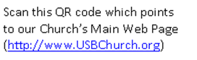

Upper Seneca Baptist Church

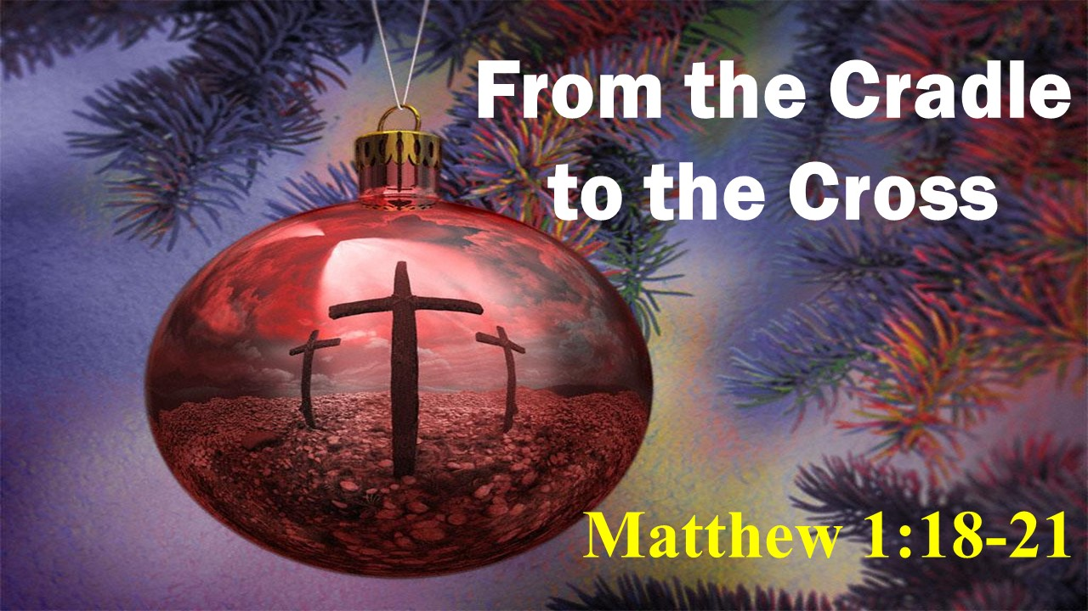

Impacting The Kingdom Of God
Isaiah 40:28-31
Psalm 31:19
One Person At A Time

Upper Seneca Baptist Church
11:00 am Sunday Worship
Sunday Worship
December 8, 2024

*Song “Welcome Song” Congregation

*Song “Joy to the World! Congregation
The Lord Is Come”

Prayer/Welcome Pastor Dennis

*Song “Good Christian Men, Rejoice” Congregation

**Message Pastor Dennis
“FROM THE CRADLE TO THE CROSS”
Matthew 1:18-21 (NIV)

Special “Sweet Little Jesus Boy” Richard Doody

Celebration of Communion

*Song “Emmanuel” Congregation

*Denotes Congregation standing
**Children will be dismissed to their classrooms following the Sermon Video (prior to the Message).
Words to hymn music printed by permission CCLI License #1159459

Your tithes and offerings will be collected at the end of the service upon leaving.



Sunday, Dec. 8, Communion Sunday
Monday, Dec. 9, Church Council Meeting
Sunday, Dec. 10, Forever Young @ “Golden Corral”
Tuesday, Dec. 10, After the Sermon
Tuesday, Dec. 10, Prayer Meeting
Thursday, Dec. 12, Women’s Bible Study
Saturday, Dec. 14, Christmas Party “Golden Corral”
Sunday, Dec. 15, Christmas Service
Sunday, Dec. 15, Cookie Swap
Sunday, Dec. 15, Gabriel Project Items Due
Thursday, Dec. 19, Women’s Christmas Party
Sunday, Dec. 22, Christmas Caroling


It has been USBC’s custom to give our pastor a Christmas love offering. As a special thanks for all of the work and sacrifice given by him and his family as they minister to us in our times of need and times of joy. This gives each person an opportunity to give from their own hearts and share their love in a very personal and meaningful way and our means to remember Pastor Dennis, his wife, Lana, their son Lucas and daughter Laney for all the love they share with us.
LOVE
OFFERING

If you wish to contribute to this special offering, please make sure to identify the purpose of your gift on your envelope, check or through Tithl.ey. You may place it in the offering plate on Sunday or send it in the mail to the church. If you need an envelope for a cash gift, see one of the ushers. Please have your gift in place by Sunday, December 31.

**REMINDER**

Church Council Meeting – Monday, Dec. 9 @ 7:00 pm

“From the Cradle to the Cross”
By Pastor Dennis Felder
December 8, 2024

Scripture: Matthew 1:18-21 (NIV)

Synopsis: During the Christmas season we gleefully sing and reflect upon the miraculous birth of Jesus Christ. However, Jesus was born for a specific purpose and that was to die upon the cross. During this Christmas message we will celebrate the birth of Christ, but we will also learn that Christmas came at a great cost.

Matthew 1:18-21 – This is how the birth of Jesus the Messiah came about: His mother Mary was pledged to be married to Joseph, but before they came together, she was found to be pregnant through the Holy Spirit. Because Joseph her husband was faithful to the law, and yet did not want to expose her to public disgrace, he had in mind to divorce her quietly. But after he had considered this, an angel of the Lord appeared to him in a dream and said, “Joseph son of David, do not be afraid to take Mary home as your wife, because what is conceived in her is from the Holy Spirit. She will give birth to a son, and you are to give him the name Jesus, because he will save his people from their sins.”

John 1:14 – The Word became flesh and made his dwelling among us. We have seen his glory, the glory of the one and only Son, who came from the Father, full of grace and truth.

What changed the world?

I. The ___________________.

Luke 2:10-11 – But the angel said to them, “Do not be afraid. I bring you good news that will cause great joy for all the people. Today in the town of David a Savior has been born to you; he is the Messiah, the Lord. This will be a sign to you: You will find a baby wrapped in cloths and lying in a manger.”
God himself, stepped out from glorious heaven and willingly came to a sinful world.

Christmas begins with the cradle, but culminates with the cross.

II. The ___________________.

Matthew1:21 – She will give birth to a son, and you are to give him the name Jesus, because he will save his people from their sins.

Matthew 26:28 – This is my blood of the covenant, which is poured out for many for the forgiveness of sins.

Jesus was the only person in history who was born with the purpose of dying.

The only cure for sin is the blood that Christ shed on the cross. Christ came as the Lamb of God, born in a manger, to bleed and die upon a cross so that you and I could be forgiven of our sins.

John 3:16 – For God so loved the world, that he gave his only begotten Son, that whosoever believeth in him should not perish, but have everlasting life.

So the next time, when you peer in the sacred cradle of Christ or when you sing Away in Manger, I pray that you will have a new perspective of Christmas and understand what it cost Christ to save you.

It is when you accept the precious gift of Jesus Christ, is when you will have a MERRY CHRISTMAS!

If you would like to listen to the sermon on-line, please visit our website at www.USBChurch.org.

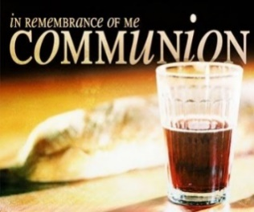
Today, I ask that you prepare your heart as we celebrate communion during our Sunday morning worship. Let this be a special time of self-reflection and change as you recall the great sacrifice that Christ made for you. He gave His all so that you could experience the true meaning of life.


The Forever Young Luncheon will take place on Tuesday, December 10, at 12:30 p.m. We will be meeting at the Golden Corral in Frederick, MD. Remember, anyone is welcome.


I love a good Christmas Party and USBC will be having such a celebration. We invite all to attend the church’s Christmas Party on Saturday, December 14, at 4pm. This festive celebration will take place at the Golden Corral (5621 Spectrum Drive, Frederick, MD 21703). During our time together we will have some fun activities and prizes. Everyone is invited and if you are planning on attending the Christmas Party at the Golden Corral, please sign up in the foyer. The cost is $16.49, plus the cost of a drink and children, based upon their age, it will range from $6.99 to $7.99. Each one will be responsible for the purchase of their meal and tip.


On Sunday, December 15, our church will be having our special Christmas Service at 11 a.m. Our Christmas Service will include a special children’s Christmas play, special Christmas music performed by our Praise Team, and will top it off by singing Christmas songs that have been enjoyed by generations. It is guaranteed to be an encouraging, uplifting, and memorable service as we celebrate the birth of Christ.

Also on December 15, we are inviting you to wear a festive Christmas outfit, sweater, or clothing that brings Christmas cheer.

On Thursday, December 19 at 6:30 p.m., the Women’s Thursday Night Bible Study will be having their Christmas Party at the church. All women are invited to this special Christmas celebration for fun, food, and fellowship. This year, there is no need to bring gifts. Your presence is what we would really love to have. For more information, please contact Connie Harding.

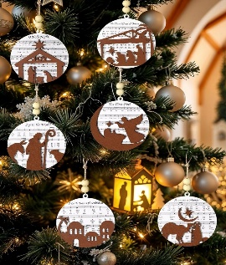
During the month of December, USBC will have special Christmas Ornaments available for a donation. All donations will be placed in the Benevolence Fund to help people in need throughout the year. The ornaments can be picked up from the table, located across from the church’s office. There will also be a small box to put your donation in.


Christmas caroling always has a way of making Christmas special. On December 22, the entire 11 a.m. worship service will consist of singing Christmas songs. As we prepare to celebrate the birthday of Jesus, we will lift up our joyous voices to sing Him praise. So, on December 22, let us warm up our voices and come ready to sing Christmas carols that will honor the birth of our Savior.


Each year, USBC promotes the Lottie Moon Christmas Offering. This special mission offering is collected during the month of December. 100% of all funds that are collected will be given to help support our international missionaries that are faithfully sharing the gospel of Christ around the world.

If you would like to give to this worthy offering, there will be special envelopes provided in your Sunday’s bulletin or it can be given online on the church’s website (http://www.usbchurch.org/Online%20Giving).


Christmas holiday is considered to be a joyous time of year. However, for some who have a loved one that has died, it can be a time of loneliness and grief. So, to help keep their wonderful memory alive during the Christmas season, we will have a Christmas Memorial Tree in the church foyer. If you have a loved one who has passed, we invite you to place a Christmas ball on the Christmas Memorial Tree to remember them.

When you walk into the church’s foyer, the Christmas Memorial Tree will be standing there. Beside the tree will be colorful Christmas balls. If you would like to honor or remember your loved one(s), take one of the Christmas balls and write their name(s) on it with markers provided. Then hang it on the Christmas Memorial Tree.

On Sunday, December 22, following our worship service, we will gather in the foyer for a special remembrance prayer. Then on Sunday, December 29, we ask that you take home your Remembrance Christmas Ball and place them in safe keeping.


If you would like to give Christmas Cards to members of your church family, we invite you to bring them to church and to personally distributed them yourself. There will not be a designated Christmas box this year to place your cards in. You will be responsible for distributing and maintaining the cards yourself. However, the church will be providing new church directories so that you can label your cards appropriately.

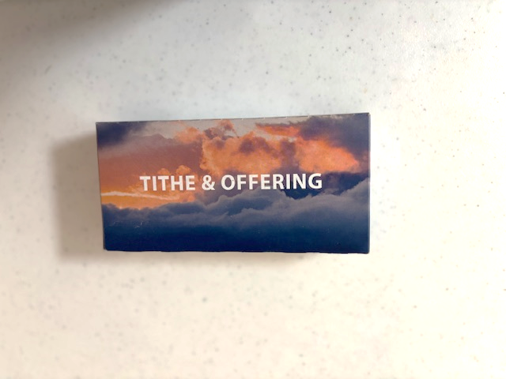
If you are planning on using offering envelopes for your tithes and offerings for 2025, the new offering envelopes will be available in the church’s foyer. Upon picking up your box of envelopes, please place your name next to the envelope box number on the signup sheet. If you have leftover envelopes from 2024, you can continue to use them in 2025.


Christmas trees, in all of their decorated beauty, are a pleasure to behold and this year we would like to see your Christmas tree in all of its splendor. So, here is the challenge. Everyone is encouraged to take a picture of your Christmas tree and email it to pastordennisusbc@hotmail.com or text the picture to 843-957-5140. The picture of your Christmas tree will then be shared with your church family in the January 2024 Newsletter. All pictures must be received by December 17.


USBC is planning a cookie swap and want to invite everyone to bring cookies to share and exchange on December 15, following the church service. Cookies will be displayed at the coffee shop and containers will be available.
Cookie
Swap



The following activities will be cancelled in December;
Sunday School (Dec. 15th & 22nd)
After the Sermon Bible Study (Dec. 24th & 31st)
Prayer Meeting (Dec. 24th & Dec. 31st)
Thursday Night Women’s Bible Study (Dec. 26th)
Church Office Closed (Dec. 25th – 29th, Jan. 1st)
Dive Deeper Bible Study will start back in January.


If you would like to make a year-end charitable tax contribution to USBC, please make sure that your financial gift is received by the church, no later than Dec. 31.


Gabriel Project of Montgomery County
(Assist pregnant/young mothers with baby needs).

Diapers (Newborn to Sizes 1-5)
Diaper Cream
Baby Lotion
Baby Shampoo
Infant Nail Clippers
Formula Bottles
New Born Pacifiers
Small Toys/Rattles
Bibs
Infant Clothing
Baby Undershirts (Onesies)
Baby Socks
Newborn caps and mittens
Receiving blankets

(Items will be collected by December 15, 2024)
October
Events

