SUNDAY, December 15, 2024
11:00 am Christmas Worship Service

TUESDAY, December 17, 2024
6:00 pm After the Sermon
7:00 pm Phone-In Prayer Meeting

THURSDAY, December 19, 2024
6:30 pm Women’s Christmas Party

CHURCH OFFICE HOURS THIS WEEK:

Mon., Dec. 16 Tues., Dec. 17 Wed., Dec. 18 Thurs., Dec. 19
9:30 am – 1 pm 9:30 am – 1 pm 9:30 am – 1 pm 9:30 am – 1 pm

How Do I Join Upper Seneca Baptist Church

- By Salvation ~ By professing faith in Jesus Christ and following Him in believer’s baptism.
- By Transfer of Letter ~ By transferring your membership from another Baptist Church.
- By Statement of Faith ~ By statement of faith in Jesus Christ.

If you have not been baptized by immersion since your conversion, you will need to follow the Lord in believer’s baptism.

When Do I Join?

At the close of every worship service as we sing the “Invitation Hymn”, the pastor stands facing the congregation. Walk to him and tell him you want to join the church or make some other decision.

Pastor Dennis Felder
Weather Policy

If the church cancels or postpones any service or activity due to inclement weather or wintery conditions, a cancelation notice will appear on the church’s Facebook page, church’s website, through church email, and on the church’s voice recorder. To access the church’s voice recorder, please dial (301) 972-3686. The church will only post a cancelation message if a service or activity is canceled or postponed.
pastordennis@usbchurch.org

23401 Davis Mill Road
Germantown, MD 20876
Phone: (301) 972-3686

Nursery & Children’s Church available
Church Office 301-972-3686

E-Mail – Church@USBChurch.org
Web Site – www.USBChurch.org

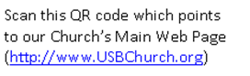

Upper Seneca Baptist Church

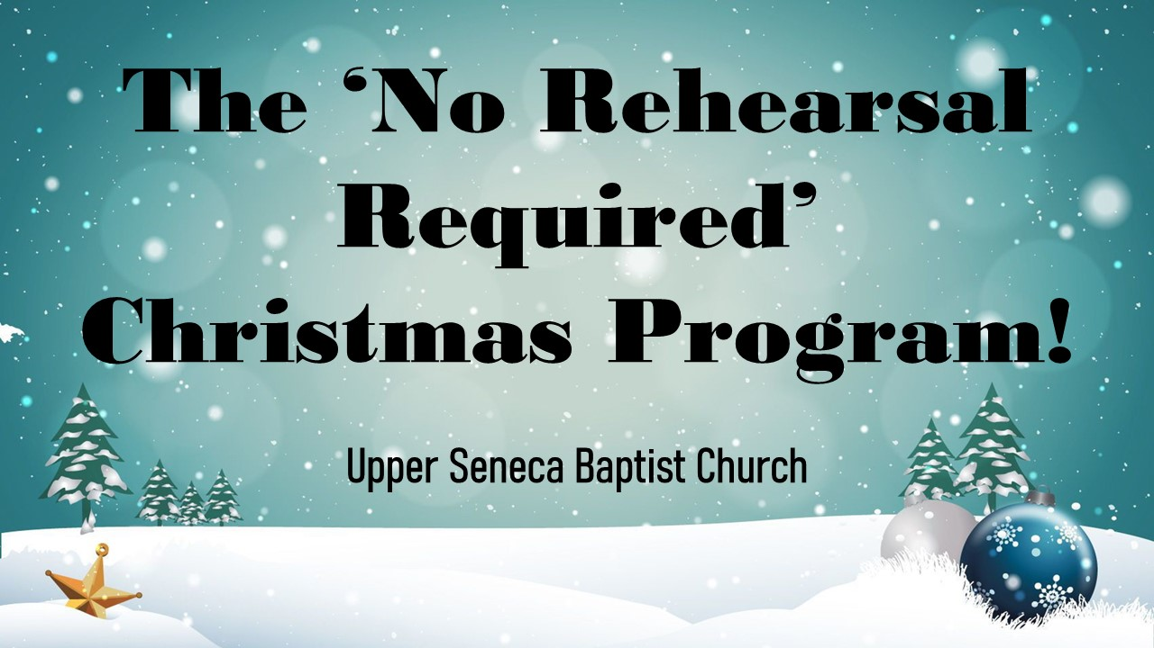

Impacting The Kingdom Of God
Isaiah 40:28-31
Psalm 31:19
One Person At A Time

Upper Seneca Baptist Church
11:00 am Sunday Worship
December 15, 2024

*Song “Joy to the World! Congregation
(Unspeakable Joy)”

Prayer/Welcome Pastor Dennis

*Song “Emmanuel” Congregation
(Hallowed Manger Ground)

Scripture Reading “Isaiah 9:2-3, 6-7” Pastor Dennis

Video “Christmas Story Told by Kids”

Christmas Play
“The ‘No Rehearsal Required Christmas Program”

Special “Breath of Heaven” Priscilla Knicley
“Away in a Manger” Congregation
“Hark! the Harold Angels Sing” Congregation
“Go Tell It on the Mountain” Congregation
“We Three Kings of Orient Are” Congregation
“Joy to the World! Congregation
The Lord Is Come”

(Narrator Adele Stokes
(Joseph) John Schultz (Mary) Audrey Jackson

(Angel) Erin Schultz (Wisemen) Steven Schultz

(Angel) Anna Schultz (Wisemen) Mike Rickoff
(Angel) Kelly Schultz (Wisemen) Josh Jackson

(Star) Thomas Schultz

(Shepherd) Timmy Smith (Shepherd) Charlene Hendricks

Special “O Holy Night!” Praise Team

Christmas Skit “The Candy Store” Pastor Dennis &
Lana Felder

Special “We Need Christmas” Praise Team

*Song “Silent Night” Congregation

Video “Silent Night”

Christmas Dance “Messiah” Kieu Luong

A Christmas Prayer Pastor Dennis

*Closing Song “We Wish You a Merry Christmas” Congregation

*Denotes Congregation standing
Words to hymn music printed by permission CCLI License #1159459

Your tithes and offerings will be collected at the end of the service upon leaving.



Sunday, Dec. 15, Christmas Service
Sunday, Dec. 15, Cookie Swap
Sunday, Dec. 15, Gabriel Project Items Due
Tuesday, Dec. 17, After the Sermon
Tuesday, Dec. 17, Prayer Meeting
Thursday, Dec. 19, Women’s Christmas Party
Sunday, Dec. 22, Christmas Caroling


Today, our church is having our special Christmas Service at 11 a.m. Our Christmas Service will include a special children’s Christmas play, special Christmas music performed by our Praise Team, and will top it off by singing Christmas songs that have been enjoyed by generations. It is guaranteed to be an encouraging, uplifting, and memorable service as we celebrate the birth of Christ.


On Thursday, December 19 at 6:30 p.m., the Women’s Thursday Night Bible Study will be having their Christmas Party at the church. All women are invited to this special Christmas celebration for fun, food, and fellowship. This year, there is no need to bring gifts. Your presence is what we would really love to have. For more information, please contact Connie Harding.

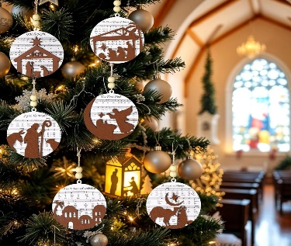
During the month of December, USBC will have special Christmas Ornaments available for a donation. All donations will be placed in the Benevolence Fund to help people in need throughout the year. The ornaments can be picked up from the table, located across from the church’s office. There will also be a small box to put your donation in.

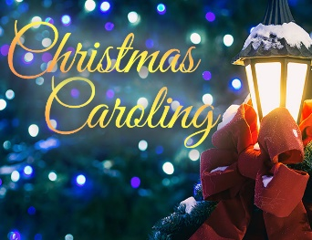
Christmas caroling always has a way of making Christmas special. On December 22, the entire 11 a.m. worship service will consist of singing Christmas songs. As we prepare to celebrate the birthday of Jesus, we will lift up our joyous voices to sing Him praise. So, on December 22, let us warm up our voices and come ready to sing Christmas carols that will honor the birth of our Savior.


Each year, USBC promotes the Lottie Moon Christmas Offering. This special mission offering is collected during the month of December. 100% of all funds that are collected will be given to help support our international missionaries that are faithfully sharing the gospel of Christ around the world.

If you would like to give to this worthy offering, there will be special envelopes provided in your Sunday’s bulletin or it can be given online on the church’s website (http://www.usbchurch.org/Online%20Giving).

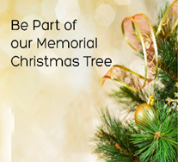
Christmas holiday is considered to be a joyous time of year. However, for some who have a loved one that has died, it can be a time of loneliness and grief. So, to help keep their wonderful memory alive during the Christmas season, we will have a Christmas Memorial Tree in the church foyer. If you have a loved one who has passed, we invite you to place a Christmas ball on the Christmas Memorial Tree to remember them.

When you walk into the church’s foyer, the Christmas Memorial Tree will be standing there. Beside the tree will be colorful Christmas balls. If you would like to honor or remember your loved one(s), take one of the Christmas balls and write their name(s) on it with markers provided. Then hang it on the Christmas Memorial Tree.

On Sunday, December 22, following our worship service, we will gather in the foyer for a special remembrance prayer. Then on Sunday, December 29, we ask that you take home your Remembrance Christmas Ball and place them in safe keeping.


If you would like to give Christmas Cards to members of your church family, we invite you to bring them to church and to personally distributed them yourself. There will not be a designated Christmas box this year to place your cards in. You will be responsible for distributing and maintaining the cards yourself. However, the church will be providing new church directories so that you can label your cards appropriately.


Christmas trees, in all of their decorated beauty, are a pleasure to behold and this year we would like to see your Christmas tree in all of its splendor. So, here is the challenge. Everyone is encouraged to take a picture of your Christmas tree and email it to pastordennisusbc@hotmail.com or text the picture to 843-957-5140. The picture of your Christmas tree will then be shared with your church family in the January 2024 Newsletter. All pictures must be received by December 17.


USBC is having their cookie swap and want to invite everyone to bring cookies to share and exchange on today, following the church service. Cookies will be displayed at the coffee shop and containers will be available.
Cookie
Swap



The following activities will be cancelled in December;
Sunday School (Dec. 15th & 22nd)
After the Sermon Bible Study (Dec. 24th & 31st)
Prayer Meeting (Dec. 24th & Dec. 31st)
Thursday Night Women’s Bible Study (Dec. 26th)
Church Office Closed (Dec. 25th – 29th, Jan. 1st)
Dive Deeper Bible Study will start back in January.


If you would like to make a year-end charitable tax contribution to USBC, please make sure that your financial gift is received by the church, no later than Dec. 31.


It has been USBC’s custom to give our pastor a Christmas love offering. As a special thanks for all of the work and sacrifice given by him and his family as they minister to us in our times of need and times of joy. This gives each person an opportunity to give from their own hearts and share their love in a very personal and meaningful way and our means to remember Pastor Dennis, his wife, Lana, their son Lucas and daughter Laney for all the love they share with us.
LOVE
OFFERING

If you wish to contribute to this special offering, please make sure to identify the purpose of your gift on your envelope, check or through Tithl.ey. You may place it in the offering plate on Sunday or send it in the mail to the church. If you need an envelope for a cash gift, see one of the ushers. Please have your gift in place by Sunday, December 31.

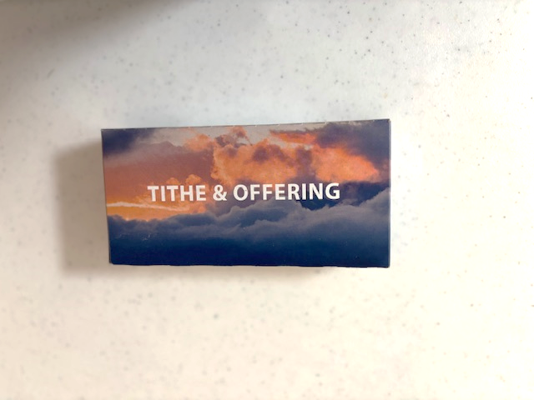
If you are planning on using offering envelopes for your tithes and offerings for 2025, the new offering envelopes will be available in the church’s foyer. Upon picking up your box of envelopes, please place your name next to the envelope box number on the signup sheet. If you have leftover envelopes from 2024, you can continue to use them in 2025.

Lucas Felder’s address at boot camp

AB FELDER, LUCAS T.
324 TRS / FLT 129
1320 Truemper St
JBSA Lackland, TX 78236-6407

DO NOT SEND FOOD OF ANY KIND

